SOLID Principle
S - Single-responsibility Principle.
O - Open-closed Principle.
L - Liskov Substitution Principle.
I - Interface Segregation Principle.
D - Dependency Inversion Principle.

https://dotnettutorials.net/course/solid-design-principles/
https://www.educative.io/blog/solid-principles-oop-c-sharp

S –
- Single-responsibility Principle.
- Each Class, Function or Module should have only one responsibility.
- Aim – Easy to maintain, test and modify

O -
- Open-closed Principle.
1) In future If we want to add some new features then we don't changes in existing because it will affect to others,
so we must to make a open for extenstion i.e. new responsibilities or functionalities can be added easily
and Closed for Modification means we should not modify the class/module/function until we find some bugs.
2) to add new functionalities by creating new derived classes, which should be inherited from the original base class.
Ex - interface open
=>5 methods
static class close
- If we want to add new method /feature then we need to add in interface and if we need to add some code changes then we will do the changes in class
3) Another way is to allow the client to access the original class with an abstract interface

Ex -
Example 1 =>
namespace SOLID_PRINCIPLES.OCP
{
public class Invoice
{
public virtual double GetInvoiceDiscount(double amount)
{
return amount - 10;
}
}

public class FinalInvoice : Invoice
{
public override double GetInvoiceDiscount(double amount)
{
return base.GetInvoiceDiscount(amount) - 50;
}
}
public class ProposedInvoice : Invoice
{
public override double GetInvoiceDiscount(double amount)
{
return base.GetInvoiceDiscount(amount) - 40;
}
}
public class RecurringInvoice : Invoice
{
public override double GetInvoiceDiscount(double amount)
{
return base.GetInvoiceDiscount(amount) - 30;
}
}

class Program
{
static void Main(string[] args)
{
Console.WriteLine("Invoice Amount: 10000");
Invoice FInvoice = new FinalInvoice();
double FInvoiceAmount = FInvoice.GetInvoiceDiscount(10000);
Console.WriteLine($"Final Invoive : {FInvoiceAmount}");
Invoice PInvoice = new ProposedInvoice();
double PInvoiceAmount = PInvoice.GetInvoiceDiscount(10000);
Console.WriteLine($"Proposed Invoive : {PInvoiceAmount}");
Invoice RInvoice = new RecurringInvoice();
double RInvoiceAmount = RInvoice.GetInvoiceDiscount(10000);
Console.WriteLine($"Recurring Invoive : {RInvoiceAmount}");
Console.ReadKey();
} }}
L –
- Liskov Substitution Principle.
- If we have a base class and derived class then derived class should be able to replace an object of the base class without bringing any errors in the system or modifying the behavior of the base class.
- That means child class objects should be able to replace parent class objects without compromising application integrity, it is said to be in Liskov Substitution Principle.

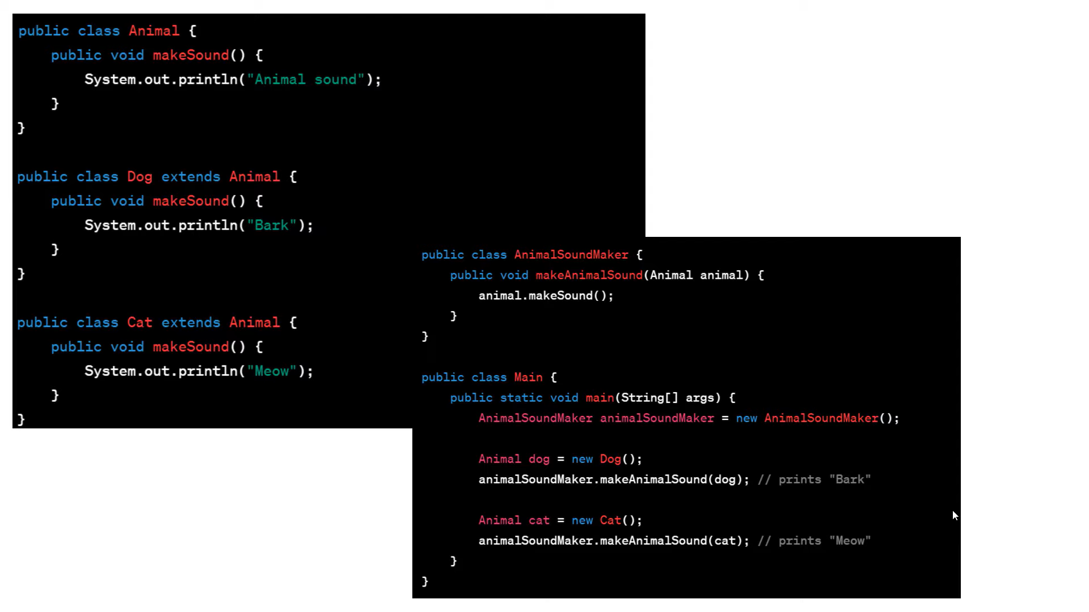

I –
- Interface Segregation Principle.
- If we declare 4 method in interface then when we inherit the interface inside we must initialise the interface method if we don’t implement then it will throw error. So for it’s forcing the class that you need to implement so when we use that interface we must implement all methos, so for that we have solution i.e. Interface Segregation Principle.
- First, no class should be forced to implement any method(s) of an interface they don’t use.
- Secondly, instead of creating large or, you can say, fat interfaces, create multiple smaller interfaces with the aim that the clients should only think about the methods that are of interest to them.
As per the Single Responsibility Principle of SOLID, interfaces should also have a single responsibility, like classes. That means we shouldn’t force any class to implement any method(s) they don’t require.
Ex –

public interface IOrder
{
void AddToCart();
}

public interface IOnlineOrder
{
void CCProcess();
}

public class OnlineOrder : IOrder, IOnlineOrder
{
public void AddToCart()
{
//Do Add to Cart
}

public void CCProcess()
{
//process through credit card
}
}

public class OfflineOrder : IOrder
{
public void AddToCart()
{
//Do Add to Cart
}
}

D – I have some doubt
- Dependency Inversion Principle.
- Like repository pattern and service pattern
- Dbcontext access into repository then repository access into services then service access into controller i.e. Dependency Injection/Inversion Principle

What is a Transaction -
A transaction in SQL Server is a group of SQL statements that are treated as a single unit and they are executed by applying the principle “do everything or do nothing” and a successful transaction must pass the ACID test.
ACID
A – Atomicity
C – Consistency
I – Isolation
D – Durability

A – Atomicity
- all the DML Statements (i.e. insert, update, delete) inside a transaction are completed successfully or all of them are rolled back.
- For example, in the stored procedure, both the UPDATE and INSERT statements should succeed. If the UPDATE statement succeeds and the INSERT statement fails, the database should undo the changes made by the UPDATE statement, by rolling it back.

C – Consistency
- database data is in a consistent state before the transaction started and also left the data in a consistent state after the transaction is completed.
- In our example, If we sending 1Rs then it must succeed or failed with 1Rs… only.

I – Isolation
- ensures that the intermediate state of a transaction is invisible to other transactions.
- IF transaction is begin then it must be succeed or should be failed and on that time it should not visible to other transaction i.e. the security of isolation

D – Durability
- Durability ensures that once the transaction is successfully completed, then the changes it made to the database will be permanent. Even if there is a system failure or power failure or any abnormal changes, it should safeguard the committed data.

GENERIC CLASS

- Generic class is used for any data type and are declared with a class declaration followed by a type parameter enclosed within angular brackets.
- Define a class with placeholders for the type of its fields, methods, parameters, etc. Generics replace these placeholders with some specific type at compile time.
Syntax –
Class <T>
{
Public <T> display()
{
//
}
}

